Integration of Ecological Indicators for the North Pacific with Emphasis on the Bering Sea: A Workshop Approach

Report on Two Pre-workshops: 25 January 2006 in Anchorage, Alaska, and 8 February 2006 in Seattle, Washington

Prepared by Gordon H. Kruse

Introduction

In spring 2005, the North Pacific Research Board (NPRB) approved and funded a proposal submitted by the North Pacific Marine Science Organization (PICES) to conduct a workshop on Bering Sea ecosystem indicators. The workshop is scheduled for June 1-3, 2006 in Seattle, Washington. As stated in the proposal, the workshop will involve four activities: (1) involve the Bering Sea and international communities in developing a set of operational objectives for the southeastern Bering Sea ecosystem, (2) evaluate two status reports on the North Pacific marine ecosystem with a goal of integrating results and streamlining the presentation, (3) investigate methodologies that monitor system-wide structural changes within the marine ecosystem, and (4) identify steps in validating indicator performance, improving the monitoring network, and integration of predictive models.

In preparation for this workshop, two pre-workshops were held – one on 25 January 2006 in Anchorage and the other on 8 February 2006 in Seattle. The former was held as an afternoon session at the conclusion of the annual Marine Science in Alaska Symposium and the latter was held as an evening session during the meeting of the North Pacific Fishery Management Council.

The purpose of this report is to summarize the proceedings of these two pre-workshops. Questions and comments were actively sought by the members of the audience. We are very grateful to Bill Bechtol of the University of Alaska Fairbanks for taking notes during the Anchorage workshop. Additional notes were taken by Gordon Kruse during both the Anchorage and Seattle pre-workshops.

Oral Presentations

Both pre-workshops followed the same format. At the Anchorage pre-workshop, Gordon Kruse of the University of Alaska Fairbanks gave an overview of this ecosystem indicators project, as well as a summary of the concepts behind an ecosystem approach to fisheries management. Diana Evans of the North Pacific Fishery Management Council staff gave an overview of the groundfish fishery management policy objectives that were developed by the North Pacific Fishery Management Council through their Programmatic Supplemental Environmental Impact Statement. The Council developed a work plan to monitor progress toward achieving these objectives. Pat Livingston of the National Marine Fisheries Service provided an overview of ecosystem processes that integrate climate and fishing stressors, as well as various indicators of these effects. Jim Overland of the Pacific Marine Environmental Laboratory provided an overview of some major historical and recent changes in climate patterns affecting the Bering Sea. Finally, Gunnar Knapp of the Institute of Social and Economic Research provided insights into socioeconomic indicators for ecosystem-based management. At the Seattle pre-workshop, all presenters were the same, except that Mark Fina of the North Pacific Fishery Management Council staff kindly agreed to substitute for Gunnar by giving the socioeconomic presentation. Thanks are expressed to all presenters, especially Diana Evans, Gunnar Knapp and Mark Fina, who are not principal investigators for this NPRB-funded project. Copies of all presentations appear in Appendices 1-5.

Comments and Questions

The Anchorage and Seattle pre-workshops were attended by approximately 75 and 20 attendees, respectively. Feedback from these participants is greatly appreciated. Below we summarize the questions and comments offered by participants in both workshops.

Anchorage Pre-workshop

Questions after Kruse presentation:

- How will invited be participants chosen for June workshop?
  - Kruse answer – We would like to be sure that participants represent both system components and geography.
  - Overland add on – we also seek participants with enthusiasm for the project.
- How do you validate ecosystem indicators?
  - Overland answer – Workshop outcomes might be recommendations for ongoing investigations; this workshop will not produce a complete set of indicators, but will likely yield an ongoing process for determining indicators.
- Is the aim of the workshop to move from broad goals to operational objectives and indicators?
  - Kruse – Yes, but there is a tradeoff between scoping all issues (horizontal dimension) and delving into the operational details (vertical dimension). The hope is to get to lower levels and perhaps find the responsible stressors to the system.
- How do you balance economic versus ecological indicators?
  - Kruse – Balancing needs to occur in a public process as a component of management. This is a societal decision.
  - Overland – The final decision on weighting of indicators will lie with the NPFMC and not within the workshop itself; it is easy to make a large list of indicators for the Bering Sea, but the hope of the workshop is to distill the list to a smaller (e.g., <20) group of indicators to present to the Council and perhaps to identify species to use as indicators.
- We know the Bering Sea is a dynamic system and we also know that some reference points (e.g., crab biological reference points) aren’t always robust, so how do we manage for performance measures in a dynamic system? The idea to “maintain” might not be the appropriate term.
  - Kruse – The NPFMC has a crab working group looking at overfishing definitions and perhaps reference definitions and this is proving to be a difficult problem. Perhaps there is a need for these definitions to be a dynamic function of the ecosystem.
- Objectives “to maintain” and those dealing with ecosystem structure are slightly on vague side. There is a need to consider ecosystem states that may change over time (multiple states of the system) and there is a need to allow ecosystem indicators to fluctuate over time. There has been considerable intertidal benthic work that indicates the existence of multiple steady states that could contribute to consideration of these concepts for this project.
  - Kruse – agreed.
- The Nature Conservancy (TNC) went through similar exercise in last few years that could serve as possible frame of reference for this project. A draft report from TWC is available.
  - Kruse – we look forward to receiving a copy of this report for consideration.
- How does new information on marine reserves and Marine Protected Areas (MPAs) get into the process and could these address differences in changes from human versus other natural factors?
  - Kruse – Ecosystem-based management is broad and encompasses MPAs, if deemed appropriate for the region. MPAs are an available tool at the disposal of the NPFMC to achieve their objectives, and they have already closed vast areas of the Gulf of Alaska and Bering Sea. MPAs can also be a useful tool to separate natural from human effects on marine systems, if they are part of a monitoring program.

Questions after Livingston Presentation:

- If you choose indicators for certain performance measures, what about potential relationships between indicators? Would you want to focus on particular indicators so that you can monitor cascading effects…e.g., how does a measure of carbon flux across the shelf relate to recruitment of a particular species?
  - Livingston – That is the purpose of putting many indicators in ecosystem chapter because we often do not initially know the relationship between particular indicators.
- You could spend a lot the research budget on just tracking indicators. So, how would you balance the budget for monitoring versus efforts to determine relationships and processes?
  - Livingston – the Alaska Fisheries Science Center will continue to monitor resources, but gaps exist in the monitoring system and there will to be need partners for both monitoring and process determination. We need to identify the gaps.
- Consider other changes in natural communities, such as range extensions.
- There are concerns about ballast water discharges which may affect range of native as well as non-native species.
- When looking at ecosystem protection, how do you define the time range to be considered in establishing indicators? How far back do you go to define your baseline?
  - Livingston – We want to look back as far as possible in time, but the real issue is how to set baseline for indicator comparisons.
- You will have a changing baseline no matter what time period is chosen. The species mix will continue to change, so how would you determine what change is natural and what induced?
  - Livingston – We are still determining the natural range of variability for many species and Jim Overland’s analyses will help to determine if we are in the same or different regimes.
- Given the concept of decadal changes and examining as steady states, how much of change in abundance can be attributed to decadal change? Also, because there is a focus on organisms of commercial importance, do you anticipate additional data collection on non-commercial species?
  - Livingston – Gordon mentioned the lack of benthic data and NMFS is trying to increase sampling of non-target species, but NMFS also needs to maintain commercial species monitoring.
- The existing 2 reports (PICES and NMFS) have data on potential indicators.
- You might want to select species that are indicators of progressive (constant or gradual) changes and not just species indicating shifts as decadal changes.
- We need clarity what a species are indicating changes in the ecosystem process. We also need to consider both small and large ecosystem scales, as well as effects on humans.
- Consider the possibility that indicators themselves may change.
- Often we can only see shifts in hindsight (i.e., note that we are still arguing over the last El Niño), so it may be naive to say we will see an ecosystem change and respond accordingly.
- There is a focus on the use of sentinel species as indicators, but you should also consider looking at aggregates, such as the biomass of a class of consumers.
  - Livingston – We are looking at community biomass levels and types of consumers.
- We are discussing ecosystem level changes, but we are still considering species-level indicators. So, it may be useful to broaden our consideration to the types of indicators.
- It is important to consider the need to examine aspects of variability over time. Consider focusing on things for which you understand the variance structure well.
- Consider a deeper examination of species richness of existing data (like Overland discussed) to get a solid understanding on spatial and temporal variability before using as a species as indicator.

Questions after Overland Presentation:

- General Comment by Overland: The Bering Sea produces $1 billion in product without the consideration of trickle down effects. Currently, there is worldwide interest in ecosystem indicators and we hope to incorporate expertise in people from other regions to help examine the Bering Sea. The Bering Sea is one of few remaining areas where natural variability is the primary determinant of fishery output. In contrast, most areas of the world are interested in how to facilitate recovery of depressed fisheries. Note that the Bering Sea is also the boundary of arctic versus subarctic system. A significant challenge will be to couple data such as the current meter M2 temperature time series with Pat’s ecosystem data on species abundance. Note that with more information, the analyses get more complex (e.g., Arctic Warm environmental cycle).
- Do you see a trend or pattern in pH over time?
  - Overland – Changes in carbon may already be impacting Aleutian corals, but this is part of a long-term process. We are seeing a global warming signal, but the changes in the Arctic are occurring faster than global warming signal changes. Others may be better able to address changes in pH.
- Temperature has a big influence, but the aspect of acidification may eliminate many life forms (those needing CaCO₄), so what would loss of those species imply to the ecosystem?
  - Overland – It is difficult to predict this.

Comments after Knapp Presentation:

- What do you mean by “institution?
  - Kruse – Institutions include NMFS, NPFMC, the courts, the State of Alaska, etc. It includes all institutions that collects fishery information and make management decisions.
- We often define objectives based on negatives, i.e., something that we don’t want to happen.

Seattle Pre-workshop

Questions after Oral Presentations:

- What does “maintain” mean?
  - Kruse answer – Maintaining a certain level of biomass for a species is problematic in a changing system, however, society does define thresholds (determinations of overfished stocks) that trigger actions. Maintain may also have some meaning for biodiversity.
- Consider diversity versus richness as an indicator. Also, consider the spatial distribution of biodiversity.
  - Livingston – We expect a latitudinal cline in diversity to change with climate. AFSC staff have been examining such changes.
- Are there desirable upper limits on species, such as particular marine mammal abundances? For example, how high does arrowtooth flounder need to get to trigger a halt to the pollock fishery or to hold the fishery harmless for their crab and halibut bycatch to foster removals of arrowtooth flounder from the system?
- Consider statistical versus functional methods to render indicators. For the latter, consider exploring groupings of species in the system by functional groups, such as winter spawners versus summer spawners, or predators of copepods versus other plankton, etc.
- Recognize that, as humans, we are modifying the system. So, we are doing ecosystem management.
  - Kruse – Humans are certainly applying stressors to the system, but I don’t think we are doing ecosystem management – that is, direct manipulations of habitat and populations with a view toward structuring the system in a way that optimizing some return to us. The system is too complex to think that we can knowingly achieve a desired outcome.
- Consider non-threshold-based indicators.
  - Kruse – Given the fact that the system has a capacity to change states, we should probably think about different thresholds for different states or perhaps a rate-based approach.
- Consider using species that we do not interact with – e.g., walrus in the Bering Sea that feed on clams – as indicators. Then, use these species to compare to those species that are related to fisheries to try to sort out our effects.
- We state up front that we are not trying to develop an ecosystem-based fishery management plan. Why aren’t we trying to do this?
  - Kruse – this is beyond the scope of our project and this task requires a public process that is best served by a group such as the NPFMC.
- We are entrenched in methods that try to maintain the mean but eliminate the variance.
- There are other views of the role of humans in the system, such as Chuck Fowler’s approach that argues that humans remove harvests at an order of magnitude too high.
- Some indicators are common across systems. Consider looking at degraded systems to see what indicators may have indicated a change in those systems.
- Consider focusing on indicators that motivate management decisions. Sea ice indicators are nice, but what management decision hinges on this indicator?
  - Kruse – Management of the fishing season for snow crabs hinges on sea ice conditions in extremely cold years. Otherwise, sea ice may act through other direct or indirect mechanisms to affect changes in species that trigger a management response.

Appendix 1. Oral presentation by Gordon Kruse.
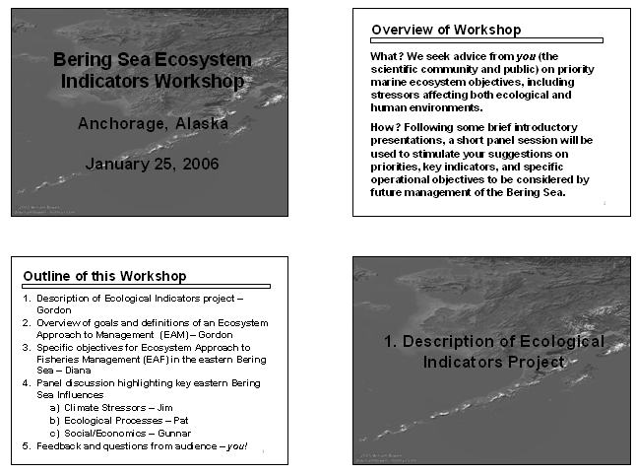
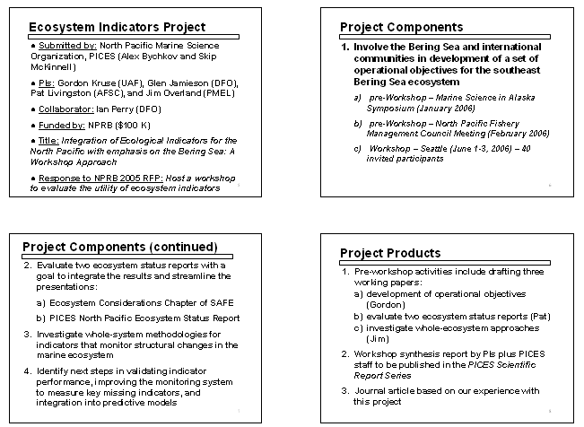

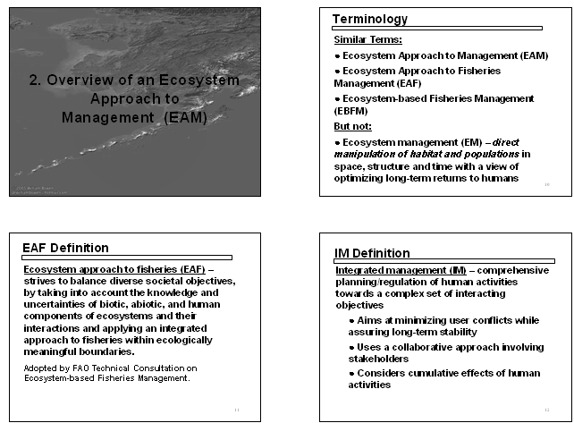
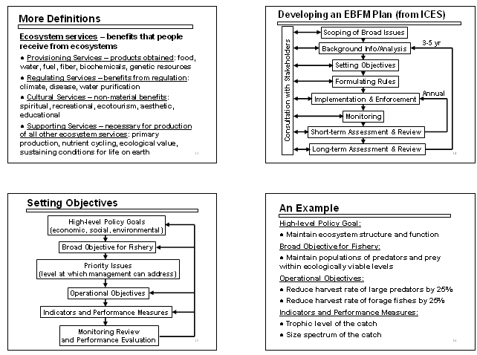
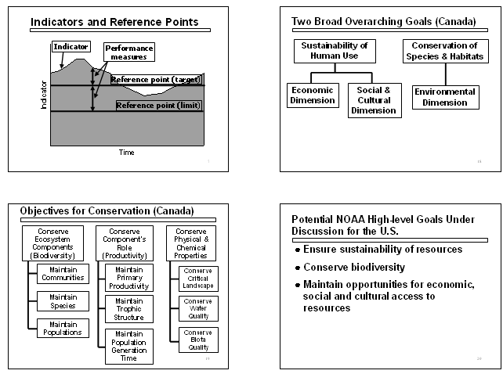
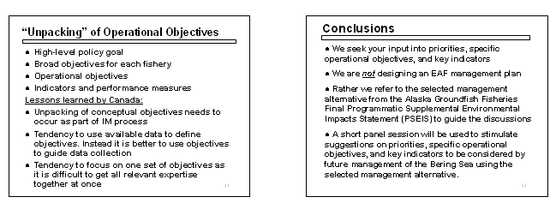
Appendix 2. Oral presentation by Diana Evans.
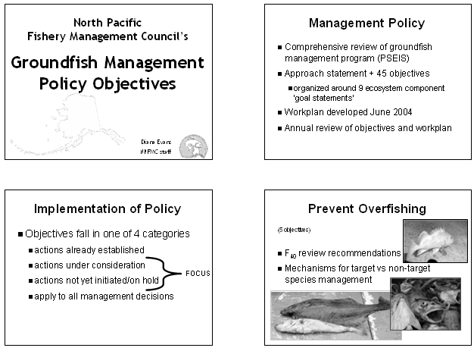

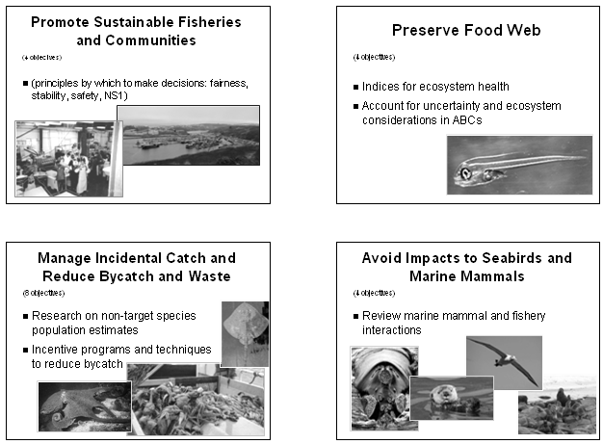
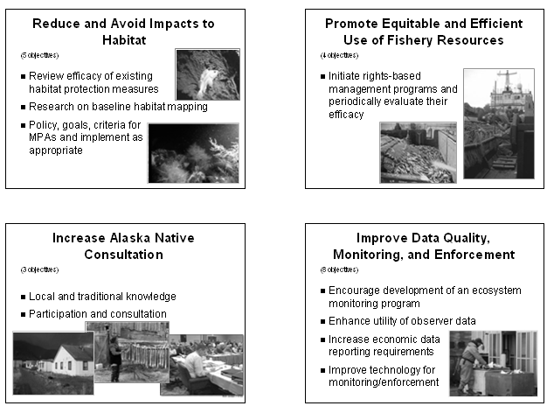
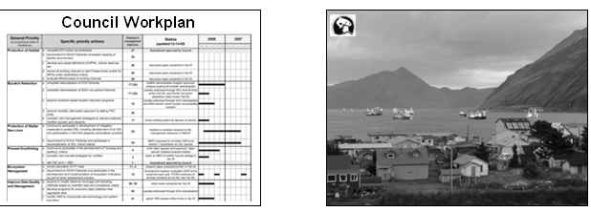
Appendix 3. Oral presentation by Pat Livingston.
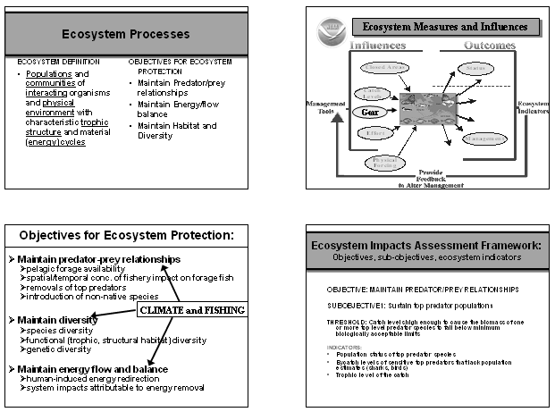
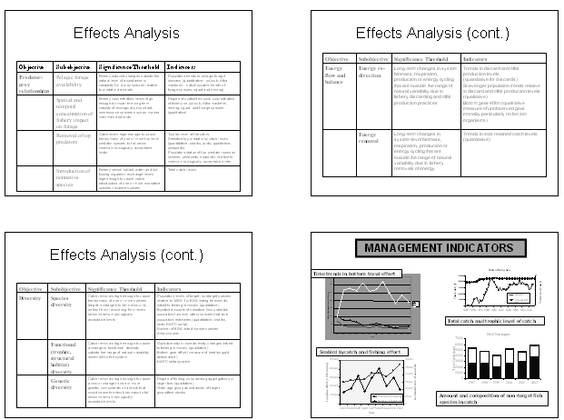
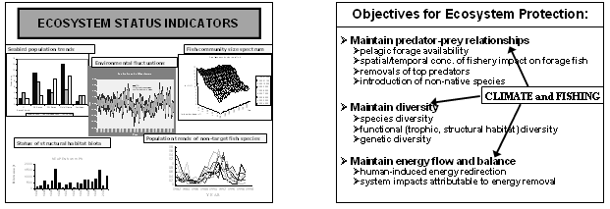
Appendix 4. Oral presentation by Jim Overland.
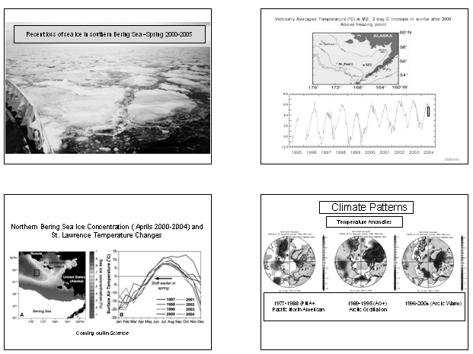
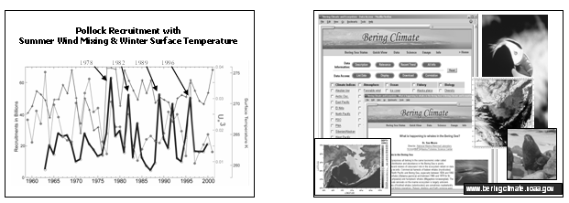
Appendix 5. Oral presentation by Gunnar Knapp.
